**IST 239 Datum and JavaScript**

**Chapter 6 Assignment 2**

Create an html document called chap6assign2.htm as explained in the following specifications:

1. Create the html file with a <title> tag that states: Chapter 6 Assignment 2
2. Create a Loan Payment Program. Use prompts to ask the user for the following:
   1. Enter the vehicle price. Like 16900
   2. Enter the down payment amount. Like 6000
   3. Enter the annual interest rate for the loan. Like 7.5

Use a prompt window for each of the above.

1. Once the input has been entered, the script should calculate the monthly payment for a 24, 36, 48 and 60 month loan.
2. Other specifications include:
   1. Page background color should be tan.
   2. Loan amount = vehicle price – down payment
   3. Monthly interest rate = annual interest rate / 1200
   4. Create a function which accepts the monthly interest rate, number of months for the loan, and the loan amount and returns the monthly payment. Use the following formulas in the function:

*var base = Math.pow(1 + monthly interest rate, number of months for the loan);*

*var payment = loan amount * monthly interest rate / (1 - (1/base));*

*return payment*

NOTE: Don’t worry if you don’t know these formulas. They are simply the two steps you use to calculate a monthly payment based on a fixed interest rate and a fixed term.

* 1. Create the heading and print the input as shown in the sample window.
  2. Using a loop, display the payments starting at 2 years and going through 5 years.
  3. Format your output to line up nicely (check out the <pre> html tag). Round the calculated monthly payment to the nearest penny. For extra credit, put in $ signs and commas. (you might want to look this up on the web)

1. See the following figure for samples of formatted output.

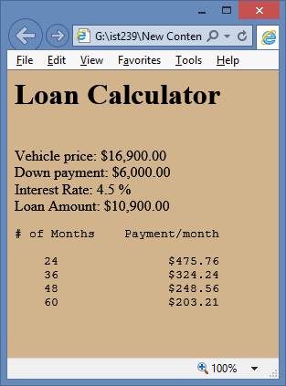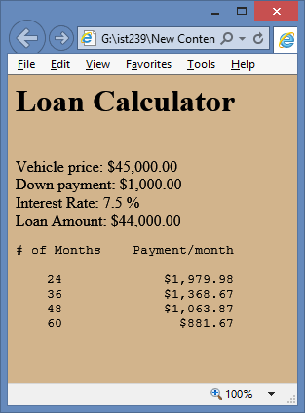

Once you’ve completed this assignment, zip the html file and submit the zip file to the appropriate Dropbox.